ABSTRACT
The objective of this project is to detect, classify and simultaneously track a moving object captured by a camera. We have used Faster RCNN (Region based Convolutional Neural Network) for the purpose of detection and classification. Faster RCNN is a modification of regular Convolutional Neural Network (CNN).While CNN only focuses on classification RCNN allows us to detect the object as well by drawing a bounding box around it. It is a state-of-the-art object detection network that reduces the running time considerably. The initial phase of the project was training the model. Both the detection model and the classifier were trained simultaneously as shown below.
Training Dataset
CNN
Model for detection
Model for Classifier
CNN

Fig: Training process
The dataset fed to the network for training consisted of images which had already been classified and detected like the one shown in the figure.
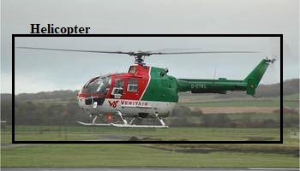
Fig: Training Dataset
Throughout the process the network tries to detect and classify the objects in the video and then compares it with the actual result. The training goes on until the output is nearly error free.
Video
Detection of Object
Classifier
Tracker
Output

Fig: Working model
Once the training phase is complete, our model is ready to be used. First step is to detect the concerned object in the video. The detection model draws a bounding box around the object and gives us the coordinates of this box. Next, we classify the detected object using the classifier, which gives us its class. Finally we get a video with a box drawn around the classified object.
Once this is complete we can track the object. Knowing the coordinates of the bounding box we can also find its centroid. The centroid gives us the approximate center of the object. By finding the rate of change of this centroid we can extrapolate the speed of the object as well as the angle it is moving at. Hence, we can track the object successfully.

Chapter 1
Machine Learning
Introduction
Machine learning is an application of artificial intelligence that uses an inductive approach to derive models from data. It incorporates self-learning procedures instead of explicit coding, making the code more versatile. It focuses on generalization process to avoid performance degradation due to nuances between training data and actual input.
In brief, machine learning operates on training data and produces a model which when provided with an input produces the desired output. This is depicted in the figure 1.1. The vertical arrows depict the training process while the horizontal ones explain the inference, which is the trained model.

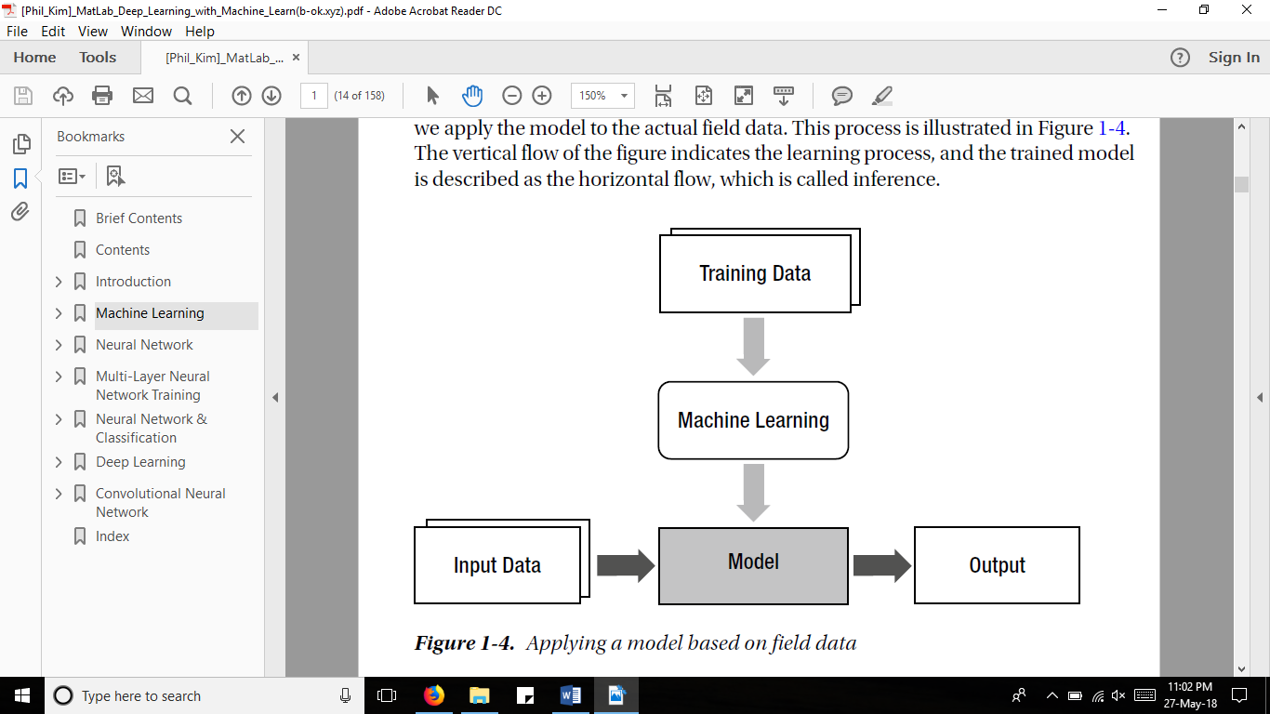
Fig1.1: Applying a model based on data

1.2. Types of Machine Learning Approaches:
    - Supervised learning
Here, each training data must consist of both the input data and correct output. It is of the format:
{Input, correct output}
The model is repeatedly revised to minimize the error between the target output and the evaluated output.

    - Unsupervised learning
Unlike the previous learning process the training data only consists of the input and is of the format: {input}
The network learns from itself and is used for investigating the characteristics of the data and preprocessing data. The learning process is accomplished via the use of weights and biases which are modified with respect to input only, and is useful in vector quantization.

    - Reinforced learning (semi-supervised learning)
This type of learning is built on observation learning. For each output the network generates, it is graded and the network decides what whether the output generated has any error in it or not. It employs the following format:
{input, some output, grade for this output}

  - Types of Machine learning Problems:
- Classification Problems.
- Regression
- Clustering
- Anomaly Detection

  - Types of machine learning algorithms
Just as there are nearly limitless uses of machine learning, there is no shortage of machine learning algorithms. They range from the fairly simple to the highly complex. Here are a few of the most commonly used models:
- This class of machine learning algorithm involves identifying a correlation -- generally between two variables -- and using that correlation to make predictions about future data points.
- Decision trees. These models use observations about certain actions and identify an optimal path for arriving at a desired outcome.
- K-means clustering. This model groups a specified number of data points into a specific number of groupings based on like characteristics.
- Neural networks. These deep learning models utilize large amounts of training data to identify correlations between many variables to learn to process incoming data in the future.
- Reinforcement learning. This area of deep learning involves models iterating over many attempts to complete a process. Steps that produce favorable outcomes are rewarded and steps that produce undesired outcomes are penalized until the algorithm learns the optimal process.

Chapter 2
Artificial Neural Network
  - Introduction
Artificial Neural Network is based on how the human brain is structured. Just like the intricate connection of neurons, ANN is a network of nodes. The connections of the neurons are mimicked using weight values. These nodes are organized in layers. Input layer is to receive the input signals, and output layer to give the final result of the network. Any layer that comes between the input and output layer is called a hidden layer. Each link between the nodes is associated with a weight. The learning process of ANNs is possible by altering these weights.
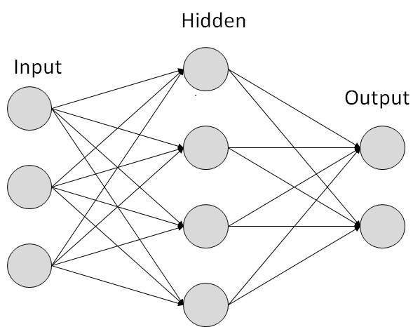
Fig2.1: Structure of ANN
The nodes are capable of taking inputs and performing computations, the result of which is passed on to every connected node. First step of the computation is calculating the weighted sum of the input signals to a node. Subsequently, we use an activation function to operate on this weighted sum to get the final output. This output helps the node decide whether it should fire the signal or not.

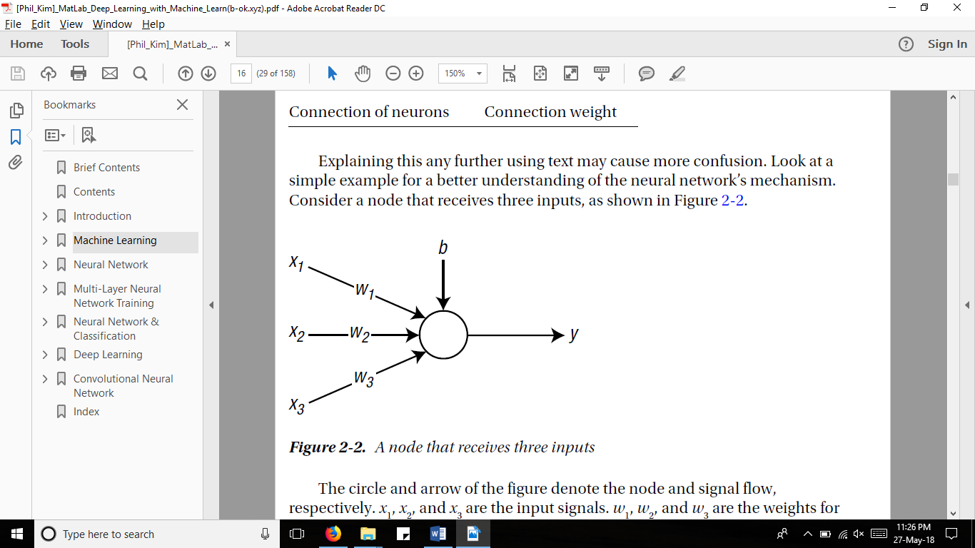
Φ(v)
Fig2.2: A node that receives three inputs

KEY TO FIG 2.2
x₁, x₂, x₃ = inputs to the node
w₁, w₂, w₃ = weights of the connections from x₁, x₂, x₃ respectively
b = bias
y = output
v= weighted sum
Φ = the activation function

In figure 2.2 the three inputs are multiplied with their respective weights and added to give the weighted sum, v, as shown below.
v = x1(w₁) _{+ x2}(w₂) + x₃(w₃) + b
v is then given as input to the activation function (Φ) to calculate the output y.
y = Φ (v)
And finally a decision is made whether the node should fire a signal or not.
The model of machine learning can be implemented for Artificial Neural Network as well. Where the vertical lines represent the training process and the horizontal ones depict the inference.
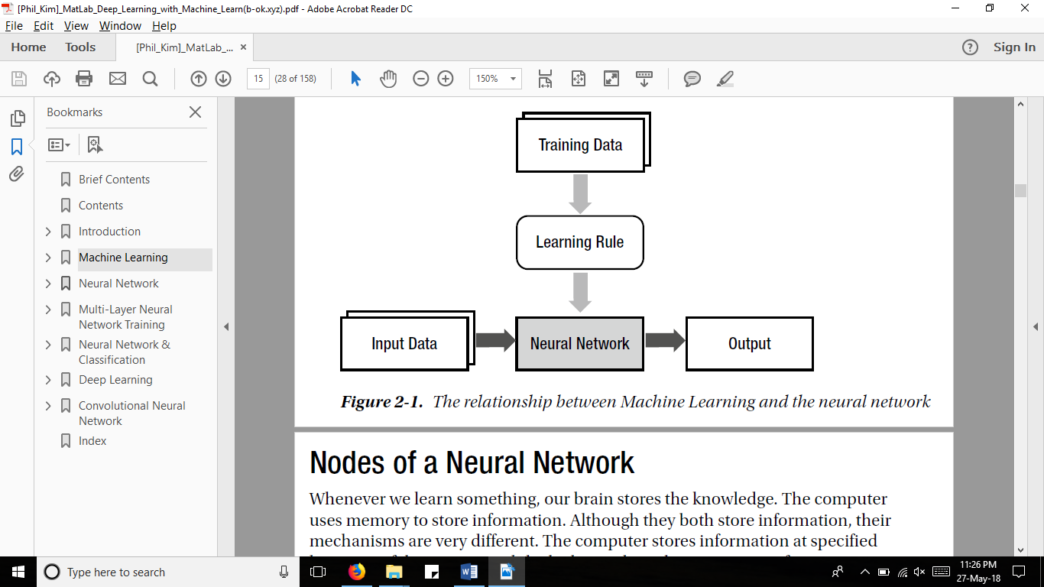
Fig2.3: Relationship between machine learning and Artificial Neural Network

  - Types of Neural Networks

    - Single layer neural network
Hidden Layer
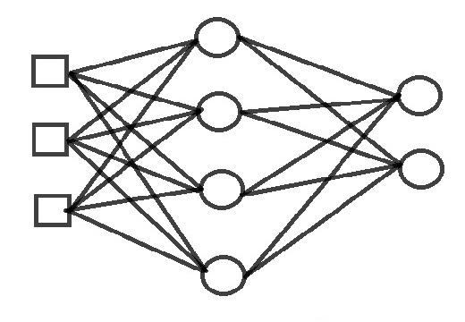
Output Layer
Input Layer
Fig2.4: Network with 3 layers, viz, input layer, hidden layer, output layer
.
The signal enters the input layer, which processes it and send it to the hidden layer which in turn processes the input and gives the data to the output layer. If the output is incorrect, we increase the number of neurons in the hidden layer to train the neural network better and get the correct output.

    - Multi- Layer Neural Network
These neural network designs have two or more hidden layers. Here the input signal is processed by the input layer and then consequently passed through multiple hidden layers and finally to the output layer.
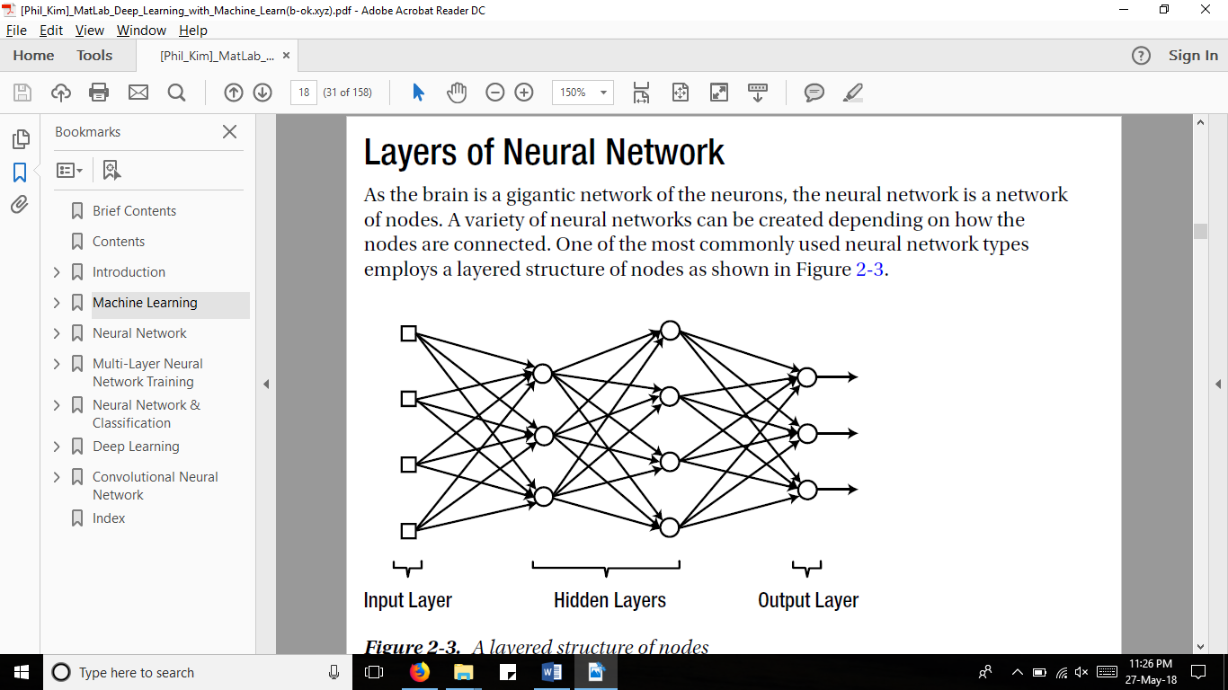
Fig 2.5: Multi-layered neural network

  - Single-layer vs Multi-layer Neural Networks
- Unlike single layer neural networks, multi-layer neural networks can solve problems which were non-linearly separable
- Drawback of using multi-layer neural network is that training takes a lot more time in comparison with single-layer.

  - Activation functions
The main purpose of activation functions in neural networks is to convert an input signal at the node to an output signal. It also gets the output only in positive values.
The output is now the input to the next layer of the network. Simply put, each neuron calculates a “weighted sum” of its input, adds a bias and then decides whether it should be “fired” or not, using the activation function. A few activation functions are listed below.

    - Sigmoid Function
The formula of this function is

$$S\left(x\right)=\frac{1}{1+e^{-x}}= \frac{e^{x}}{e^{x}+1}$$

where;
x is the input of the activation function
e is exponential constant
S(x) is the output of the activation function

It has a characteristic “S” shaped curve or sigmoid curve.

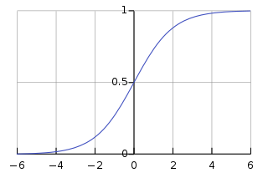
Fig 2.6: Graph of Sigmoid function

    - Tanh (Hyperbolic tangent) Function
The mathematical formula of this function is
$$f\left(x\right)= 1-\frac{e^{-2x}}{1+e^{-2x}}$$
where;
x is the input of the activation function
e is exponential constant
f(x) is the output of the activation function

Now its output is zero centered because its range in between -1 to 1 i.e -1 < output < 1. Hence optimization is easier in this method hence in practice it is always preferred over Sigmoid function. But still it suffers from Vanishing gradient problem.

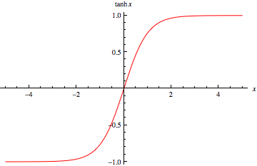

Fig 2.7: Graph of tanh function

    - ReLu (Rectified Linear) Function

The ReLu function,
$$R\left(x\right)=max⁡(0,x)$$
where;
x is the input of the activation function
R(x) is the output of the activation function

i.e. if x<0, R(x)=0 and if x>=0, R(x)= x.

It has become very popular in the past couple of years. It was recently proved that it had 6 times improvement in convergence from Tanh function.

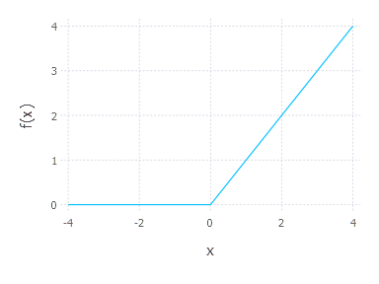
Fig 2.8: ReLU function

  - Types of ANN:

    - Feedforward Neural Network
A feedforward neural network is a biologically inspired classification algorithm. It consist of a (possibly large) number of simple neuron-like processing units, organized in layers. Every unit in a layer is connected with all the units in the previous layer. Data travels in only one direction, it enters the input nodes and exits through the output nodes. In simple words, it has a front propagated wave and no back propagation.
Application of Feed forward neural networks are found in computer vision and speech recognition where classifying the target classes are complicated. These kind of Neural Networks are responsive to noisy data and easy to maintain.
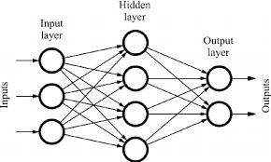
Fig2.9: Feedforward Neural Network

    - Recurrent Neural Network
A recurrent neural network (RNN) is a class of artificial neural network where connections between nodes form a directed graph along a sequence. In this network, the first layer is formed similar to the feed forward neural network with the product of the sum of the weights and the features. The recurrent neural network process starts once this is computed, this means that from one time step to the next each neuron will remember some information it had in the previous time-step. This makes each neuron act like a memory cell in performing computations. The application of Recurrent Neural Networks can be found in text to speech (TTS) conversion models.
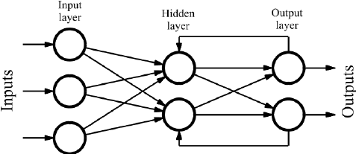
Fig2.10: Recurrent Neural Network

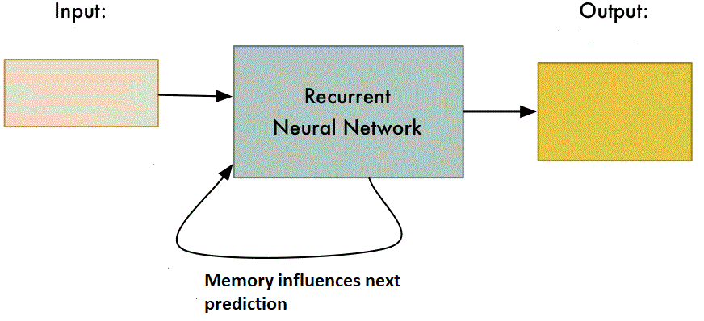
Fig 2.11: Basic model of Recurrent Neural Network

    - Convolutional Neural Network
Convolutional neural networks are similar to feed forward neural networks, where the neurons have learn-able weights and biases. Its application have been in signal and image processing which takes over OpenCV in field of computer vision.
Below is a representation of a convolutional neural network, in this neural network, the input features are taken in batch wise like a filter. This will help the network to remember the images in parts and can compute the operations. These computations involve conversion of the image from RGB scale to Gray-scale.

Image
Filter
Fig2.14: Filter being applied on an image

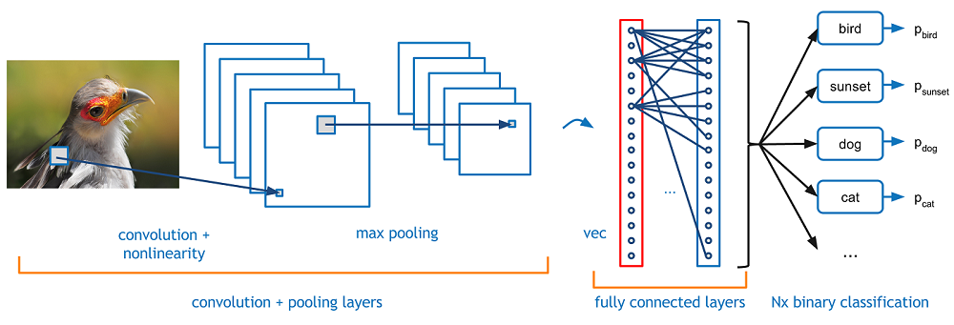
Fig2.15: Convolutional Neural Network
How CNN Works
- Convolution Layer- The input to this layer is our image. The computer perceives these images as an array of pixels as shown above. Depending on the resolution and size of the image, it will see a 32 x 32 x 3 array of numbers (The 3 refers to RGB values). Each of these numbers is given a value from 0 to 255 which describes the pixel intensity at that point.
In the convolution layer we make use of filters (or kernels), which are arrays of numbers called weights. These filters must be of the same depth as the image i.e. 3(E.g.: 5x5x3). The first position the filter is the top left corner. As the filter is sliding, or convolving, around the input image, it is multiplying the values in the filter with the original pixel values of the image. These multiplications are all summed up. So now you have a single number which is just representative of when the filter is at the top left of the image.

Fig2.16: How filters work

This process is repeated for every location on the input volume. (Next step would be moving the filter to the right by 1 unit, then right again by 1, and so on). The resulting array is called a feature map or activation map.

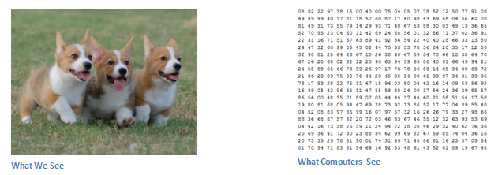
Fig 2.17: Representation of how a computer perceives an image
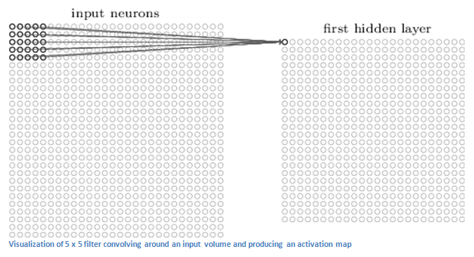
Fig 2.18: Result of first convolution layer
- FIRST LAYER OF CNN: It has filters for detecting simple colors, curves, and lines. The more filters, the greater the depth of the activation map, and the more information we have about the input.
- DEEPER INTO THE NETWORK: When we go through another convolution layer, the output of the first convolution layer becomes the input of the 2nd convolution layer. Now when you apply a set of filters on top of that (pass it through the 2nd convolution layer), the output will be activations that represent higher level features. Types of these features could be semicircles (combination of a curve and straight edge) or squares (combination of several straight edges). As you go through
the network and go through more convolution layers, you get activation maps that represent more and more complex features. By the end of the network, you may have some filters that activate when there is handwriting in the image, filters that activate when they see pink objects, etc.

- Pooling Layer: The pooling layer combines the outputs of neuron clusters at one layer into a single neuron in the next layer. For example, max pooling uses the maximum value from each of a cluster of neurons at the prior layer.

Fig2.19: Max and Mean Pooling

- Fully Connected Layer: This layer takes the output from the convolution + pooling layer and returns an N dimensional vector where N is the number of classes that the program has to choose from. For example, if you wanted a digit classification program, N would be 10 since there are 10 digits. Each number in this N dimensional vector represents the probability of a certain class. For example, if the resulting vector for a digit classification program is [0 .1 .1 .75 0 0 0 0 0 .05], then this represents a 10% probability that the image is a 1, a 10% probability that the image is a 2 and so on. The way this fully connected layer works is that it looks at the output of the previous layer, which represents the activation maps of high level features, and determines which features most correlate to a particular class. For example, if the program is predicting that some image is a dog, it will have high values in the activation maps that represent high level features like a paw or 4 legs, etc. Basically, it looks at what high level features most strongly correlate to a particular class and has particular weights so that when you compute the products between the weights and the previous layer, you get the correct probabilities for the different classes.

Why do we use CNN for Image Classification?
- Directly using the original images for image recognition leads to poor results, regardless of the recognition method; the images should be processed to contrast the features.
- Before ConvNet, the feature extractor has been designed by experts of specific areas. Therefore, it required a significant amount of cost and time while it yielded an inconsistent level of performance. These feature extractors were independent of Machine Learning. Figure 2.19 illustrates this process.
Fig 2.20: Different processes for feature extraction and classifier
- ConvNet includes the feature extractor in the training process rather than designing it manually. The fact that ConvNet turned the manual feature extraction design into the automated process is its primary feature and advantage. Figure 2.20 depicts the training concept of ConvNet..

Chapter 3
Training
3.1. Introduction
Training is the process through which we allocate weights to our filters, which will be used in our final model. For single layer neural networks, certain learning rules were employed. They update the weights and bias levels of a network when a network simulates in a specific data environment.
3.2. Learning Rules for single hidden layer
Different rules were developed and modified. But most of them are just some modification of the perceptron learning rule. These work only on single layer neural networks
3.2.1. Perceptron Learning Rule
Perceptron learning rule or Learning process is a method or a mathematical logic which improves the artificial neural network's performance. First we take the network's actual output and compare it to the target output in our training set. If the network's actual output and target output doesn't match we know something went wrong and we can update the weights based on the amount of error.
STEP 1- CALCULATING OUTPUT
Output = f (input1 × weight1 + input2 × weight2 + ...)
OR
$$o=f\left(\sum_{i=0}^{n}{ (}xi(wi))\right)$$
where;
xi is the respective input, where i= 1,2,3,4,…
wi is the respective weight, where i=1,2,3,4
STEP 2- ERROR CALCULATION
Error = target – output
OR
$$E=t-o$$
where;
E is the error
t is the target output or the desired output
o is the actual output

STEP 3- ADJUST WEIGHTS
$weight change=learnig rate×error ×input$
OR
$$∆w= r×E×x$$
.
Where;
r is the learning rate
E is the error in the learning rate
x is the input
3.2.2. Delta Rule
Delta rule is very similar to the Perceptron learning rule. It uses gradient descent search. Gradient descent is a first-order iterative optimization algorithm for finding the minimum of a function. To find a local minimum of a function using gradient descent, one takes steps proportional to the negative of the gradient (or approximate gradient) of the function at the current point.
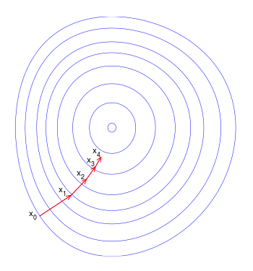
Fig3.1: Illustration of gradient descent

STEP 1
Output = f (input1 × weight1 + input2 × weight2 + ...)
OR
$$o=f\left( \sum_{i=0}^{n}{ (}xiwi)\right)$$
where;
xi is the respective input, where i= 1,2,3,4,…
wi is the respective weight, where i=1,2,3,4…
o is the output
STEP 2- ERROR CALCULATION
$E= \frac{∑(ti-oi) ^{2}}{2}$
Where;
E= error in the output
ti = target output at ith iteration, where i=1,2,3,…
oi = output at ith iteration, where i=1,2,3,…

STEP 3 – ADJUST THE WEIGHT
$$Wi=Wi+ ∆Wi \\ ∆Wi= η∑\left(ti-oi\right)Xi$$
Where;
Wi = Weight at the i^{th} iteration
ƞ = Learning rate
ti = target output at ith iteration, where i=1,2,3,…
oi = output at ith iteration, where i=1,2,3,…
Xi is the respective input, where i= 1,2,3,4,…

Learning Rule used in project
The training process in CNN takes place through supervised learning. We can divide training into four main divisions:
- Forward Pass
- Loss Function
- Backward Pass
- Weight Update
These processes are carried out using back-propagation.

  - Back Propagation Algorithm

The back-propagation algorithm trains a given feed-forward multilayer neural network for a given set of input patterns with known classifications. When each entry of the sample set is presented to the network, the network examines its output response to the sample input pattern. The output response is then compared to the known and desired output and the error value is calculated. Based on the error, the connection weights are adjusted. The backpropagation algorithm is based on delta learning rule in which the weight adjustment is done through mean square error of the output response to the sample input. In this algorithm the error is calculated for each layer in the backward direction i.e. from the last layer to the first hidden layer. This helps us train multilayer neural networks better.

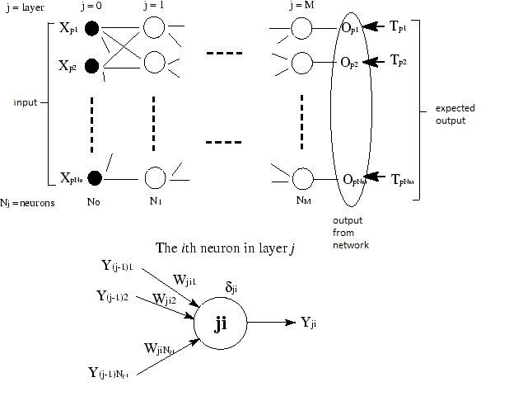
Fig3.2: Back Propagation Algorithm

STEP 1- CALCULATING OUTPUT
Output = f (input1 × weight1 + input2 × weight2 + ...)
OR
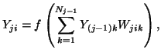

where;
Yi is the respective input, where i= 1,2,3,4,…
Wi is the respective weight, where i=1,2,3,4…
Yji is the output

STEP 2- ERROR CALCULATION
The error for the last layer is:
While error for the hidden layers is calculated as follows:
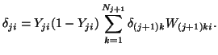

STEP 3- WEIGHT UPDATE
The weight of each node is updated using the formula
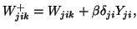
Where β is called the learning rate. It is the weight adjustment factor which varies from 0 to 1.

Chapter 4.
Deep Learning
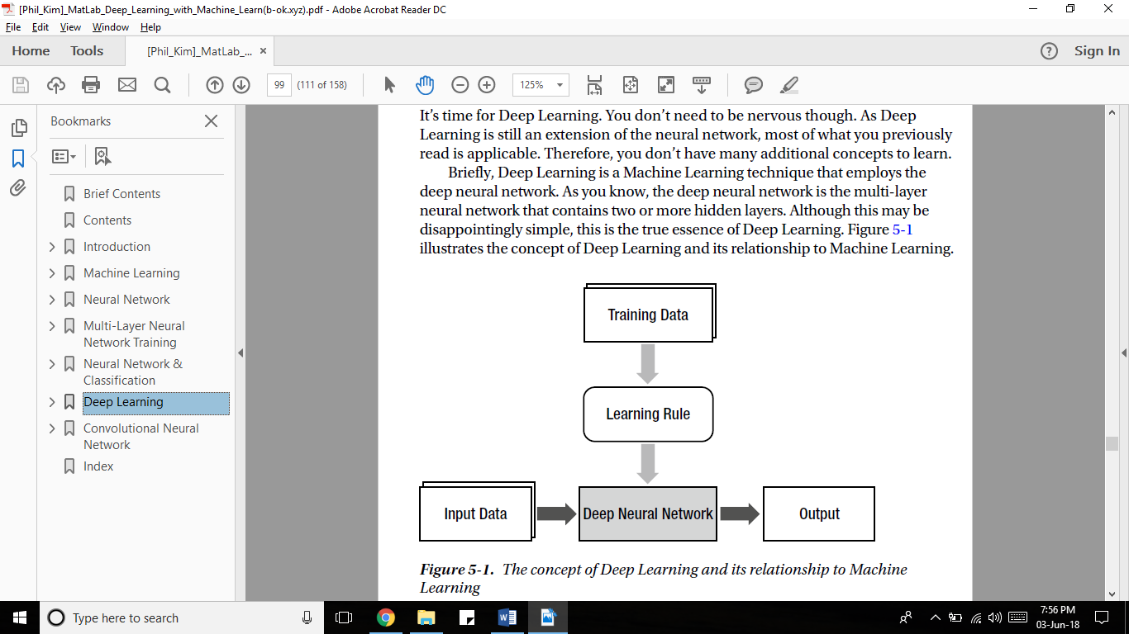
Fig 4.1: Relationship between Artificial Neural Network and deep Neural Network

4.1. Meaning of Deep Neural Network
- Learning methods which have deep architecture. By deep architectures, we mean those architectures which have two or more hidden layers.
- It often allows end-to-end learning.
- It often contains stacked “neural network”. Thus, deep learning usually indicates “deep neural network”

4.2. Uses of deep learning:
- Speech Recognition
- Computer Vision
- Natural Language Processing

4.3. Deep Learning can work with:
- Pre training with unsupervised learning
- Convolutional Neural Network
- Recurrent Neural Network
- Parallel Processing of big data
- Advanced algorithms for optimization, activation, and regularization.

  - Why we used Deep Learning
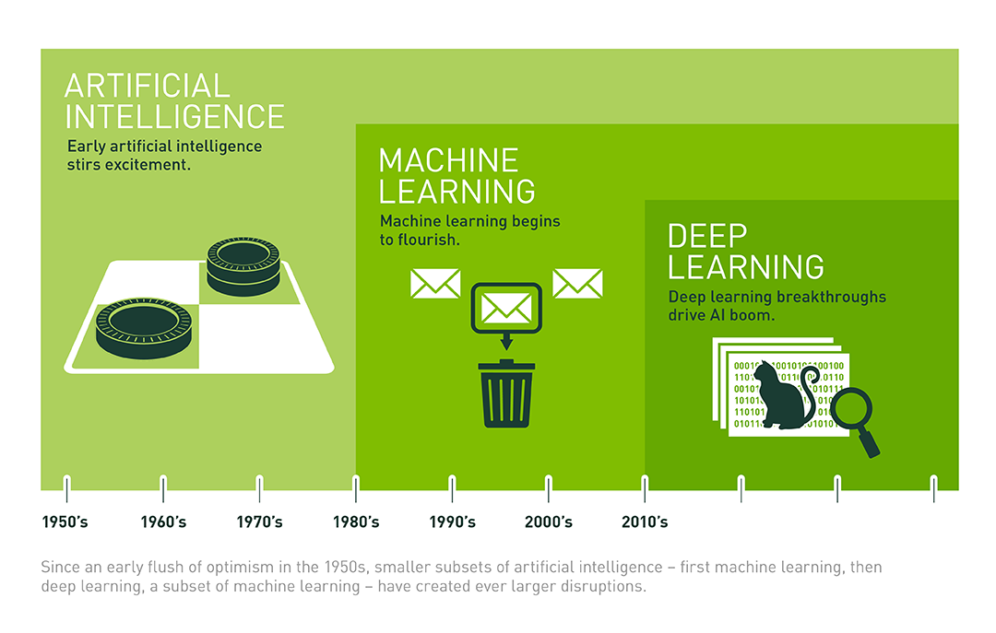
Fig 4.2: Evolution of Artificial Intelligence

In recent years we have seen a shift from Machine Learning to Deep Learning. The contributing factors for this change are:

- CREATING NEW FEAUTURES - One of the main benefits of deep learning over various machine learning algorithms is its ability to generate new features from limited series of features located in the training dataset. Therefore, deep learning algorithms can create new tasks to solve current ones.
- ADAVNCED ANALYSIS - Due to its improved data processing models, deep learning generates actionable results when solving data science tasks. While machine learning works only with labeled data, deep learning supports unsupervised learning techniques that allow the system become smarter on its own. The capacity to determine the most important features allows deep learning to efficiently provide data scientists with concise and reliable analysis results.
- END TO END LEARNING - ML divides tasks into small pieces and then combine received results into one conclusion while DL solves the problem on the end-to-end basis
  - Tools for Deep Learning in Python

    - Theano
Theano can also be called the mentor because it led to other deep learning libraries.For example, Lasagne and Keras are both built on Theano. At its core, Theano is a library for doing math using multi-dimensional arrays. It’s fast, and it’s optimized using GPU (140x faster than CPU!).
In other words, it serves as the building blocks for neural networks.

    - Tensorflow
Google’s own AI team developed TensorFlow, and they recently made it open source.
TensorFlow allows efficient numerical computation using data flow graphs. It’s marketed as a Theano 2.0 from scratch that has learned from the lessons of Theano. Its support from a powerhouse like Google is also promising. Even so, Theano is still faster than TensorFlow in many ways, and it supports a wider range of operations. However, one benefit of TensorFlow is that it supports distributed computing out-of-the-box. This makes training deep networks on multiple GPUs much easier.

    - Lasagne
Lasagne is a lightweight wrapper for Theano. It allows you to build and train neural networks using Theano’s optimized computing.
In Lasagne, you’ll still need to get fairly low-level and declare each network layer. It simply provides modular building blocks on top of Theano. The end result is that your code will be verbose… but you can at least program with NN structures instead of multi-dimensional arrays. Treat Lasagne as the compromise between Theano’s flexibility and Keras’s simplicity.

    - Keras
Among all the Python deep learning libraries, Keras is favorite. First, Keras is a wrapper that allows you to use either the Theano or the TensorFlow backend! That means you can easily switch between the two, depending on your application. Second, it has beautiful guiding principles: modularity, minimalism, extensibility, and Python-nativeness. In practice, this makes working in Keras simple and enjoyable. Finally, Keras has out-of-the-box implementations of common network structures.

    - OpenCV
OpenCV is a library of programming functions mainly aimed at real-time computer vision. It is not technically used for deep learning, rather it is used for computer vision problems.
WHY WE USED TENSORFLOW
- Backed by Google, TensorFlow has the advantage of the seamless performance, quick updates and frequent new releases with new features.
- Offers great debugging methods.
- The libraries can be deployed on a gamut of hardware machines, starting from cellular devices to computers with complex setups.
- TensorFlow allows coders to iterate quickly, train models faster and run more experiments
- TensorFlow reduces errors by 55%-85%.

4.6. Tools for Deep Learning in MatLab:
For matlab we have many pre-built libraries and functions for literally everything. This also includes deep learning.
Some toolbox which are used in Matlab are:
- Neural Network toolbox
- Deep Learning toolbox
- Image Processing toolbox
- Computer Vision toolbox

4.7. Deep learning requirement for the project:

4.7.1. Classification
It consists of classifying an image into one of many different categories. In recent years classification models have surpassed human performance and it has been considered practically solved all thanks to different models of CNN. Hence, we delved more into CNN in the coming topics

Chapter 5.
Digital Image Processing
5.1 Image
An image is a picture that has been created or copied and stored in electronic form.
In technical terms, a digital image is a representation of two-dimensional image as a finite set of digital values, called pixels.
5.2. Pixel
A minute area of illumination on a display screen, one of many from which an image is composed. In technical terms, a pixel is a physical point in an image. So basically, it is the smallest controllable element of a picture represented on the screen.
Pixel values typically represent gray levels, colors, heights, opacities etc.

5.3. Common Image formats include:
- Grayscale or Black and White (1 sample per point)
- RGB i.e., Red, Green and Blue (3 samples per point)
- RGB and Alpha, i.e., Opacity (4 samples per point )

5.4. Digital image processing
Digital Image processing basically deals with manipulation of digital image through a computer.
We need Digital image processing for two major tasks:
- Improvement of pictorial information for human interpretation
- Processing of image data for storage, transmission and representation for autonomous machine perception.
Where image processing ends is where fields such as image analysis and computer vision begins.
5.5. Types of Image Processing:
- Image to Image Transformations (Low level image processing).
This includes adding noise into image, removing noise from the image, image sharpening.
Used for:
- Image Enhancement
- Scaling, resizing, zooming, morphing one object to another.
- Deburring and grid line removal.
- Image to Information/Attributes Transformations (Mid-level image processing)
This includes object recognition and segmentation.
Used for:
- Image Compression
- Image analysis which includes image segmentation, feature extraction, pattern recognition.
Computer-aided detection and diagnosis.
- Information/Attributes to Image Transformations (High Level Process)
This includes scene understanding, autonomous navigation.
Used for:
- Decompression of compressed image data.
- Reconstruction of image slices from CT or MRI raw data.
- Computer graphics, animations and virtual reality.

5.6. Video:
A video combines a sequence of images to form a moving picture.

Chapter 6.
Convolutional Neural Network
  - Introduction
A convolutional neural network is a class of deep, feed-forward artificial neural networks, most commonly applied to analyzing visual imagery. The working has already been explained in section 2.5.3.
  - Types of Convolutional Neural Network Architectures:
    - LeNet (1990s) –
Developed during the starting period of CNN. Has a simple architecture of feed-forward neural network. The research work was hindered because the computational power was not able to handle data efficiently.
    - AlexNet (2012) –
Alexnet is a deeper and much wider version of the LeNet. It was a significant breakthrough with respect to the previous approaches and the current widespread application of CNNs can be attributed to this work.
    - ZF Net (2013) –
ZFNet (short for Zeiler & Fergus Net). It was an improvement on AlexNet by tweaking the architecture. This is the pre-trained neural network model we are going to use in our Model.
    - GoogLeNet (2014) –
Its main contribution was the development of an Inception Module that dramatically reduced the number of parameters in the network (4M, compared to AlexNet with 60M).
    - VGGNet (2014) –
Its main contribution was in showing that the depth of the network (number of layers) is a critical component for good performance.
    - ResNets (2015) –
ResNets are currently by far state of the art Convolutional Neural Network models and are the default choice for using ConvNets in practice.
    - DenseNet (August 2016) –
The Densely Connected Convolutional Network has each layer directly connected to every other layer in a feed-forward fashion. The DenseNet has been shown to obtain significant improvements over previous state-of-the-art architectures on five highly competitive object recognition benchmark tasks.

6.3. Object Recognition from still Image
Matlab Code for object Recognition

clc;
clear all ;
close all;
net = alexnet; % calling the pre-trained network from matlab
picture = imread('lol.jpg') %reading the input picture
picture = imresize(picture,[227,227]); % resizing the picture so that it can be compared to alexnet
label = classify (net,picture); %storing the name of the object in the variable “label”

figure
imshow(picture); %displaying the image with the name of the object
text(10,20,char(label),'color','red') %giving specifications to the text displayed
output

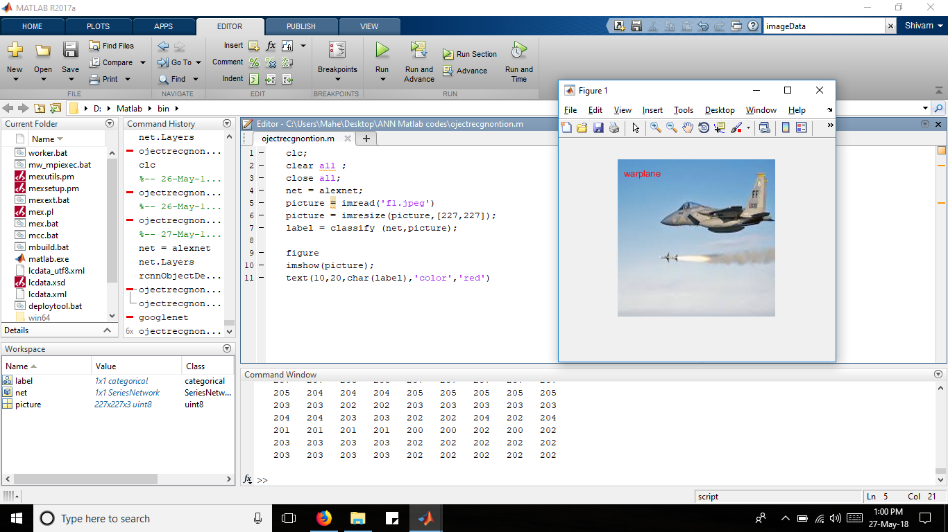

Fig 6.1: A warplane getting detected using CNN

6.4. Limitations of Convolutional Neural Network
The biggest problem with moving from CNN to R-CNN was that even though it is great in object detection, the problem lies with localization. Localization of the object in a particular frame is one of the major challenges which was solved by using R-CNN. Hence, we moved onto R-CNN.

Chapter 7
Region based Convolutional Neural Network
RCNN aims at detection and classification of the object. It considerably reduces the running time as compared to simple CNN networks. This network aims at extracting regions that have high probability of containing the concerned object, for the purpose of detection. However RCNN had a few drawbacks which were then later overcome by Fast-RCNN, which was then further improved in the Faster-RCNN model. Below each architecture is explained in detail.

7.1. R-CNN

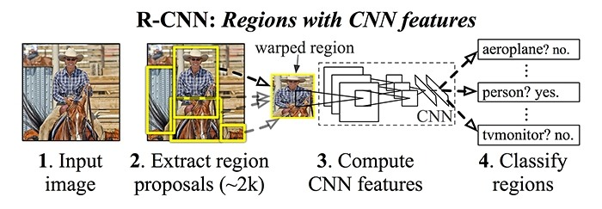
Fig7.1: Architecture of R-CNN

7.1.1. Model Workflow
- Pre-train a CNN network on image classification tasks.
- Extract those regions that might have objects. Classification of the object isn’t done in this stage. We propose these category-independent objects using selective search.

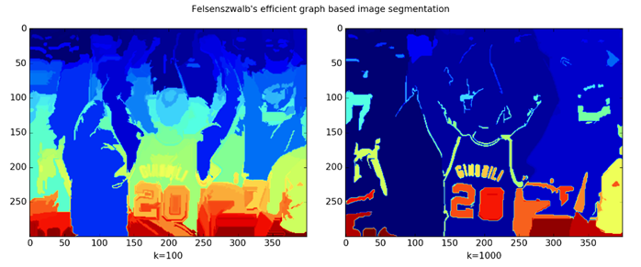
Image before applying selective search
Grouping of areas with similar color, texture, or intensity

Fig7.2: Selective Search
Selective search is a common algorithm to provide region proposals that potentially contain objects.
    - At the initialization stage, apply Felzenszwalb and Huttenlocher’s graph-based image segmentation algorithm to create regions to start with.
    - Use a greedy algorithm to iteratively group regions together:
      - First the similarities between all neighboring regions are calculated based on texture, color, or intensity.
      - The two most similar regions are grouped together, and new similarities are calculated between the resulting region and its neighbors.
    - The process of grouping the most similar regions (Step 2) is repeated until the whole image becomes a single region.
- The regions received are warped to have standard square size as required by CNN
- After this we pass the proposed regions through a modified version of AlexNet, to compute the features.
- On the final layer of CNN, RCNN adds a Support Vector Machine (SVM) that simply classifies whether this is an object, and if so what object. This is step 4 in the above diagram.
7.1.2. Problems Faced
Training an R-CNN model is expensive and slow, as the following steps involve a lot of work:
- Running selective search to propose 2000 region candidates for every image;
- Generating the CNN feature vector for every image region (N images * 2000).
- The whole process involves three models separately without much shared computation: the convolutional neural network for image classification and feature extraction; the top SVM classifier for identifying target objects; and the regression model for tightening region
7.2. Fast R-CNN
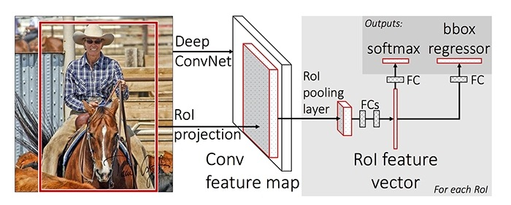
Fig7.3: Architecture of Fast R-CNN
7.2.1. ROI (Region of Interest) Pooling
It is a type of max pooling to convert features in the projected region of the image of any size, h x w, into a small fixed window, H x W. The input region is divided into H x W grids, approximately every sub-window of size h/H x w/W. Then apply max-pooling in each grid.

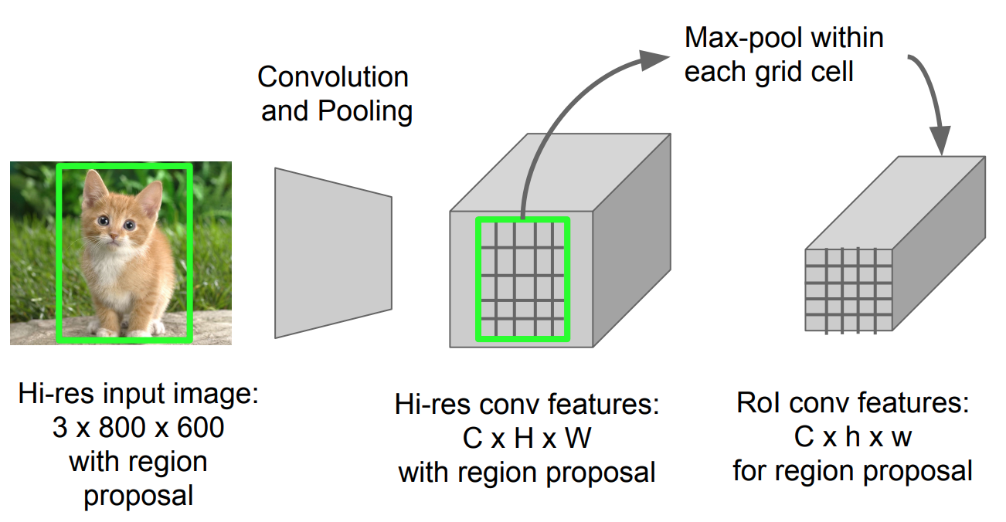
Fig 7.4: ROI pooling

7.2.2. MODEL WORKFLOW
- First, pre-train a convolutional neural network on image classification tasks.
- Propose regions by selective search (~2k candidates per image).
- Alter the pre-trained CNN:
  - Replace the last max pooling layer of the pre-trained CNN with a RoI pooling layer. The RoI pooling layer outputs fixed-length feature vectors of region proposals. Sharing the CNN computation makes a lot of sense, as many region proposals of the same images are highly overlapped.
  - Replace the last fully connected layer and the last softmax layer (K classes) with a fully connected layer and softmax over K + 1 classes.
- Finally the model branches into two output layers:
  - A softmax estimator of K + 1 classes (same as in R-CNN, +1 is the “background” class), outputting a discrete probability distribution per RoI.
  - A bounding-box regression model which predicts offsets relative to the original RoI for each of K classes.

7.2.3. IMPROVEMENT
It unified three independent models into one jointly trained framework and increasing shared computation results. Instead of extracting CNN feature vectors independently for each region proposal, this model aggregates them into one CNN forward pass over the entire image and the region proposals share this feature matrix. Then the same feature matrix is branched out to be used for learning the object classifier and the bounding-box regressor. In conclusion, computation sharing speeds up R-CNN.
7.2.4. PROBLEMS FACED
Fast R-CNN is much faster in both training and testing time. However, the improvement is not dramatic because the region proposals are generated separately by another model and that is very expensive.

7.3. Faster R-CNN:
7.3.1. IMPROVEMENT
In Faster-RCNN instead of using a separate selective-search algorithm on the features extracted from CNN we use region proposals network for detection of objects. The time cost of generating region proposals is much smaller in RPN than selective search.
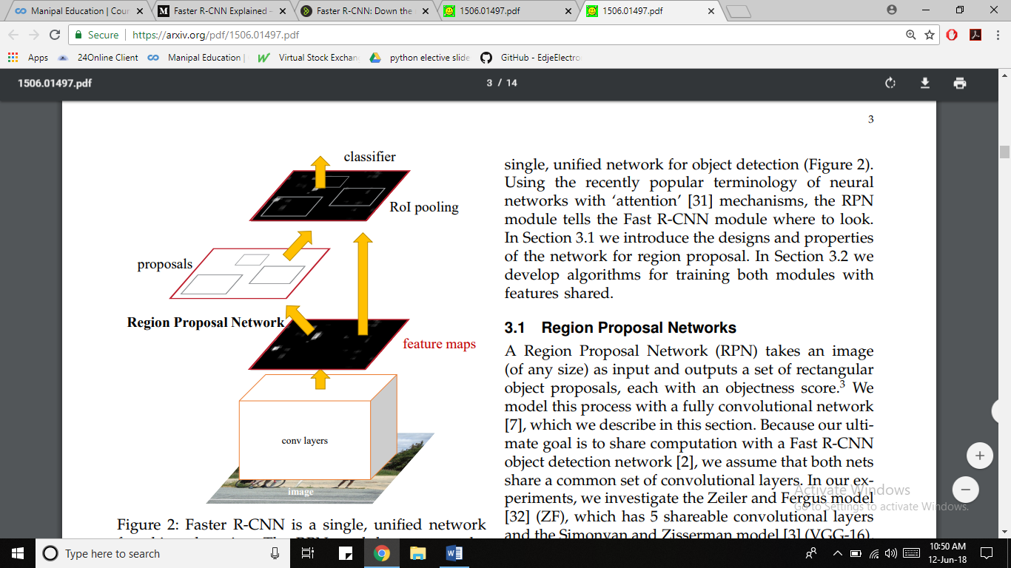
Fig7.5: Faster RCNN architecture

STEP 1: Convolutional layers
- We pass the image through convolution layers to extract feature maps from it.
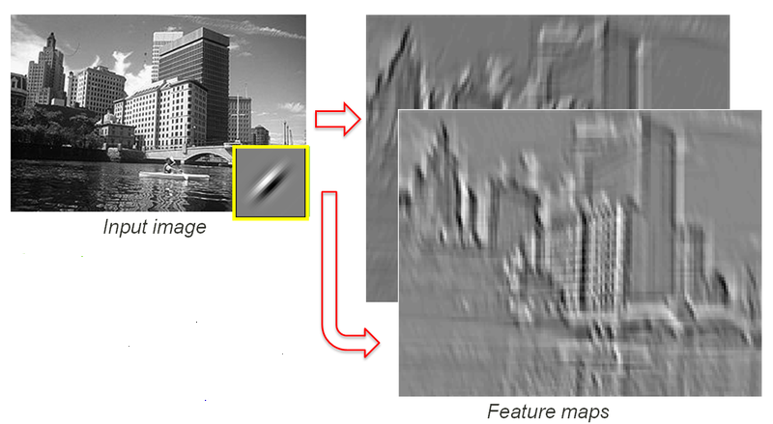
Fig 7.6: Extraction of feature maps

STEP 2: Region Proposal Network:
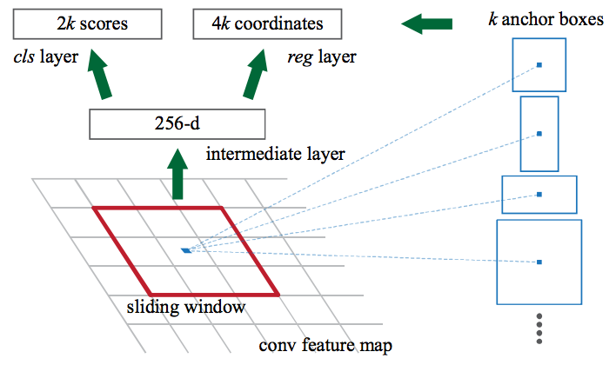
Fig 7.7: Region Proposal Network
- A sliding window is passed over the CNN feature maps
- As a result we get potential bounding boxes and scores, which gives us the probability of having an object
- Since anchors usually overlap, proposals end up also overlapping over the same object. To solve the issue of duplicate proposals we use a simple algorithmic approach called Non-Maximum Suppression (NMS).
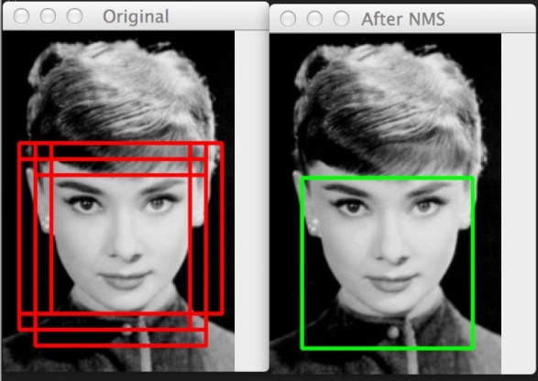
All possible bounding boxes
Optimum bounding box chosen
Fig 7.8: Creating Anchors using NMS

7.3.2. Anchors
Creating boxes/Anchors - Anchors play an important role in Faster R-CNN. An anchor is a box. In the default configuration of Faster R-CNN, there are 9 anchors at one position of an image. The following graph shows 9 anchors at the position (320, 320) of an image with size (600, 800). The purpose of these anchors is to cover as many pixels as possible and incorporate the aspect ratios of objects as well.
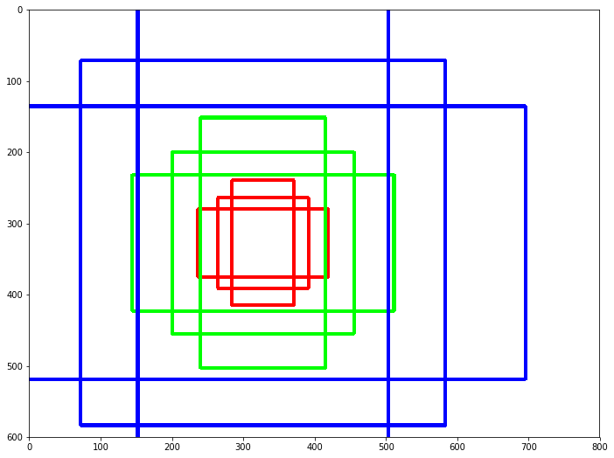
Fig 7.9: Anchors around a single position (320,320) in an image

7.3.3. HOW THE RPN WORKS
In order to get region proposals we need to train the RPN. For the training process we need a training dataset. This dataset has images with bounding box drawn around the labeled object. These bounding boxes are called ground truth boxes. We slide the window across the image and label the anchors having the higher overlaps with ground-truth boxes as foreground, the ones with lower overlaps as background. Once trained we use this network for object detection.

STEP 3: Region of Interest Pooling
- After the RPN step, we have a bunch of object proposals with no class assigned to them.
- The simplest approach would be to take each proposal, crop it, and then pass it through the pre-trained base network. Then, we can use the extracted features as input for a classifier. The main problem is that running the computations for all the 2000 proposals is really inefficient and slow.
- Faster R-CNN tries to solve, or at least mitigate, this problem by reusing the existing convolutional feature map. This is done by extracting fixed-sized feature maps for each proposal using region of interest pooling. Fixed size feature maps are needed for the R-CNN in order to classify them into a fixed number of classes.

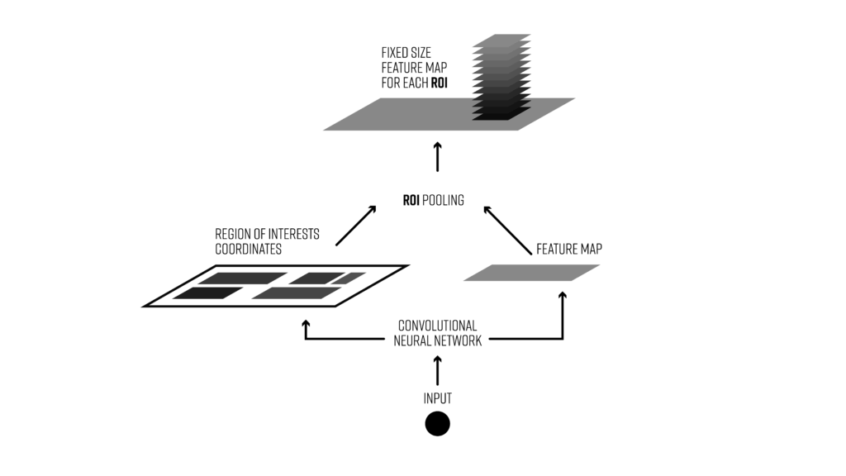
Fig7.10: ROI Pooling
STEP 4: Classifier’
- We finally need to use these features for classification. The classifier tries to mimic the final stages of classification CNNs where a fully-connected layer is used to output a score for each possible object class.
- R-CNN has two different goals:
  - Classify proposals into one of the classes, plus a background class (for removing bad proposals).
  - Better adjust the bounding box for the proposal according to the predicted class.
- The paper mentioned two ways: alternatively train the RPN, and the final classifier and regressor; train them at the same time jointly. The latter is 1.5 times faster with similar accuracy.
Output:
Thus the output will be an image in which we get bounding boxes around those objects for which the CNN was trained for.

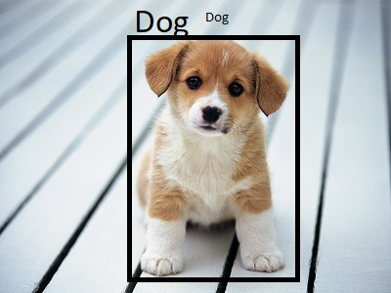
Fig7.11: the output image with the object identified and inside the bounding box

Until here, we are able to detect the object and classify it into different classes in an image. A bounding box is created around the object and the class appears on top of the bounding box.
In a video, if the object is moving, the bounding box is created around it and it keeps on moving if the object keeps on moving. More than one bounding boxes are created in case more than one recognizable object appears in the video frame.
Now, we are supposed to track the object. Tracking is discussed in the next Chapter.

Chapter 8
Project in Brief
Training Phase
Training is the first step of the project. It consists of training the model for detecting the object in the image. To do so we provide a set of labeled pictures as input, this is called the training set. We carry out supervised learning by giving an input image and its correct output, which is the name of the object in the image and the coordinates of the box bounding it. While training the model constantly compares its output with the one given. Once the error in predicting the correct output is negligible, we stop the training as our model is ready to use.
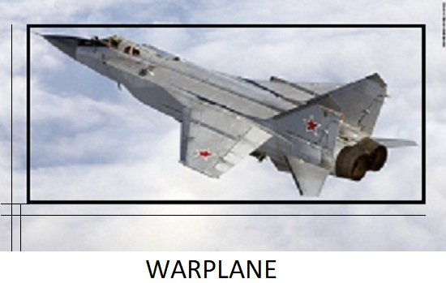
Training Dataset
Train Network
Database/ Trained Network
Output class: Plane
y_min, y_max, x_min, x_max

Via Supervised Learning

Maps features to classes:
- Warplane
- helicopter

End
Start

Predictive Phase
Once our model is trained we use it on our input video. We start off by converting the video into a set of frames, or still images. Each image is processed and then converted back to a video. First, we localize all the objects present in the image. However, this may even include objects that we don’t want to detect. So in the next step we discard the unnecessary localizations and draw a bounding box around only the ones required. Once detected the object is ready to be classified. With the help of the model we give the object the correct class label.
Start
Input Video
Video to images
Set of Frames
Frame 1 Frame 2 Frame 3 Frame 4
Object Availability
Feature Discarded
Comparison of Features
Feature Extraction
LOCALISATION

Frames

Output video
NO YES
Continued

Remove boxes around those objects that don’t belong to class C1 or C2

Remaining Objects

Object classified as C1 or C2

Output video

Comparison of Features
End
Continued
DETECTION

CLASSIFICATON

Database/ Trained Network

Set of Frames
Frame 1 Frame 2 Frame 3 Frame 4

`Chapter 9
Tracking
8.1. Introduction
Video tracking is the process of locating a moving object (or multiple objects) over time using a camera. Video tracking can be a time consuming process due to the amount of data that is contained in video. The objective of video tracking is to associate target objects in consecutive video frames. The association can be especially difficult when the objects are moving fast relative to the frame rate.
8.2. Two Dimensional Tracking
We have discussed two dimensional tracking in the flowchart on the next page. What we mean by two dimensional tracking is tracking the object in x nd y axis and find out the kinematics parameter of the object in the same coordinates.
Following the same procedure, we get the output video containing the name of the object, centriod of x and y axis, and velocity in x and y direction.
To do so, we find out the centroid of the bounding box which gives the aprximate center of the object. Subsequently, we find the rate of change of the centroid in both the x and y directions. This way, we get the speed along both the axes. By finding the net magitude of these speeds we can find the net velocity. Hence, we now have the velocity with which the object is moving. To find the direction of it’s movement we find the angle it makes using the formula mentioned below. Therefere, we can succesfuly track the object.
The limitation of this project is that it can track objects which move perpendicular to the camers. In case the object is approacing or movinf further from the camera, change in x and y coordinates of the centroid will give errranous readings of the velocity. In this situation we must moniter the rate of change of the z-axis coordinates of the object.

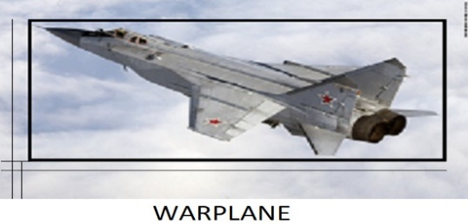
Classified and Detected Image

Find Centroid of the box
Centroid Coordinates
Velocity in x & y direction

Magnitude and direction of total Velocity

Velocity of Object
Find Angle of Movement
Angle in which the object is moving
End
Start

Classified and detected Image:
The image has a bounding box around the concerned object as well as a label indicating its class. We also have the coordinates of the box in terms of xmin, ymin, xmax, ymax.
Centroid of the box:
Subsequently, we obtain the coordinates of centroid of the box. In doing so we get the approximate center of the object.
x_centroid = $\frac{x_\min{+ } x_max}{2}$
y_centroid = $\frac{y_\min{+ } y_max}{2}$
Velocity in x & y direction:
We define the value of t by
t = $\frac{1}{number of frames per second}$
Now, we find the instantaneous velocity at each instance in the x, y direction (V_x , V_y, respectively) with the formula:
$V_x$ = $\frac{ (x_centroid)' - x_centroid}{t}$
V_y = $\frac{ (y_centroid)' - y_centroid}{t}$
Where, (x_centroid)’ is centroid coordinates inthePrevious instance.
(x_centroid) is centroid coordinates at the present instance.

Magnitude of the Net Velocity:
To calculate the value of the net velocity, we use the vector law.
Hence,
V = $\sqrt{{(V_x)}^{2}+{(V_y)}^{2}}$

Direction of the Velocity:
We find the direction of the velocity with the following formula:
$Ɵ$ = $\tan^{-1}(\frac{V_y}{V_x})$

8.3. Three Dimensional Tracking
To counter the problem of when the tracked object changes orientation over time, we have come across various solutions.
8.3.1. Using Conditional Statements to observe the change in z-axis
This method involves finding the difference between the areas of the bounding box in the previous frame and the current frame. If the object is approaching then the are will increase, else decrease. The major drawback with this approach is that sizes of various objects may vary and we cannot compute accurately if an object is far or just small, because in both the cases area occupied by boundig box is less. We may overcome this error by defining a threshold for each class of objects and apply a conditional statement to check.

8.3.2. Computer stereo vision
Computer stereo vision is the extraction of 3D information from digital images. By comparing information about a scene from two vantage points, 3D information can be extracted by examining the relative positions of objects in the two panels.
The detailed analysis of computer stereo imaging is out of scope of this report, because it involeves a whole new field of stereoscopy.
Computer stereo imaging is still a developing field in Computer vision and robotics. A physical binocular like object is developed to view the the depth of the objects.

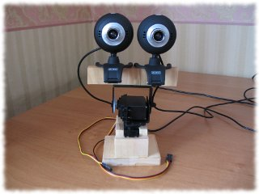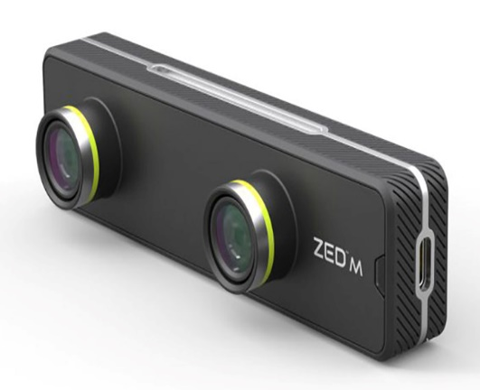
Fig 9.1: A customised and a fully-developed stereo imaging device

As can be seen from the output on the next page, if an object is near, it displays in red color, and as we go down further, the color shifts from red to green to blue. The farthest object is blue in color.
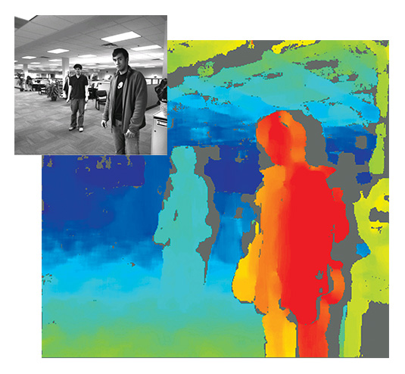
Fig 9.2: A typical output form the stereo imaging
OUTPUT
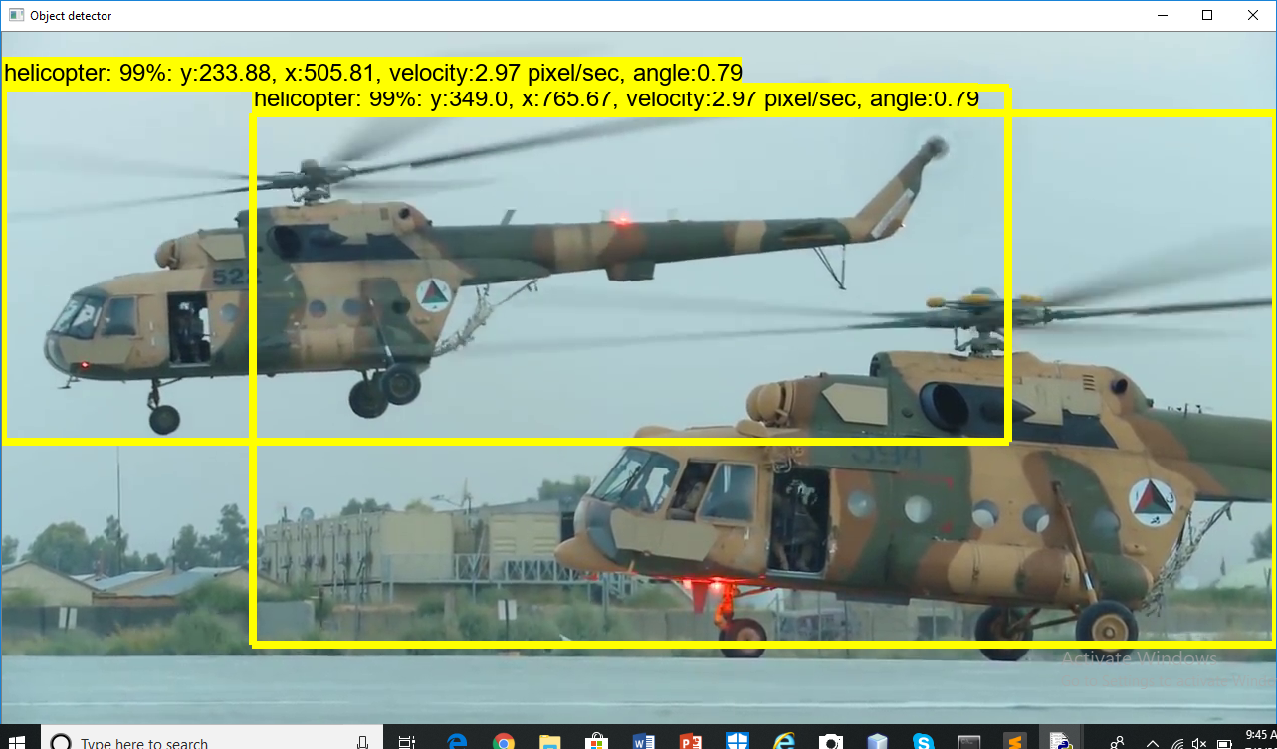
Fig 9.3: Output with name and bounding box around the object

The unit of measurement in the above picture is pixels. However we can convert them into real spatial units by calibrating a single image against known values, then applying that calibration to your un-calibrated image. To do so we can take an image from the camera we are going to use for the video, find the actual distance occupied and the distance in pixels, using that we can get a conversion factor.
Conversion factor = (actual distance/distance in pixels)
On multiplying this conversion factor with the pixel units we can get the actual spatial units desired.

Conclusion
The aim is to build a robust and novel moving object detection, classification and tracking algorithm that can detect, classify and track the object in a real world scenario.
We have trained the model on 300 images each of helicopter and warplanes. The model is also trained to draw a bounding box around helicopter/warplane if it detects that these objects are present in the image provided.
After creating the model, it will be ready to detect and draw a bounding box around any helicopter/warplane.
Now, since the video is organized into frames, we have used the Image processing tool box to convert the video into a set of images. Each image is individually passed through the model in order to detect the objects the model is trained on. If the object is present in the image, it will be detected, the name of the object will be displayed at the top and a bounding box will be created around that object. This happens for each image. We have used tensorflow library in python for training and testing of the code.
We again use the image processing toolbox to combine the set of images at the output and display it as the output video. The only difference will be that a bounding box will be created around it and the name of the object will be displayed at the output video.
This method was tested on several video sequences. The trained model was able to detect all of the moving objects in the sequences which were trained on the model.
For calculating the kinematics parameters, we applied the following logic. The output clearly draws a bounding box on the moving object present in the scene and thus the coordinates of the box can be determined. Once the coordinates of the box are determined, we take out the centroid of the box. Once the centroid of the object is determined, we can easily calculate the net velocity by subtracting the position of the previous centroid points with the present centroid points, divided by the time taken per frame. Thus, we get the velocity of the object as well.
Thus, the output video will contain a bounding box around the object detected, with the object’s name displaying on the top, the current centroid position of the object, and the instantaneous velocity of the object.
This algorithm has wide range of applications in day to day life. It can be used to track a cricket ball, the kinematics of an athlete, etc. We have used this model to detect and track an enemy warplane/helicopter, if and when it appears in the field of view of the camera. The main problem we face while implementing this project is computational power.
With increased computational power, and with the addition of the CUDA Core GPU, this project is very much feasible to be used as an actual object detection and tracking model in Navy Projects.
Bibliography
This report has been compiled with valuable contribution from:

BOOKS AND PAPERS
- MatLab Deep Learning with Machine Learning, by Phil Kim
- Neural Network Design by Martin T. Hagan, Howard B. Demuth, Mark Hudson Beale, Orlando De Jesús
- T. Malavika and M. Poornima,-Moving object detection and velocity estimation. International Journal of Engineering Research and Technology
(IJERT) Vol. 2 Issue 1, January- 2013
- R. C. Gonzalez University of Tennessee, Richard E. Woods MedData Interactive, Digital Image Processing, Second Edition, Prentice Hall.
- M. A. A. Dewan, M. J. Hossain, and O. Chae. Background independent moving
Object segmentation for video surveillance. IEICE Transactions, 92-B(2):585598,
2009.
- S. Denman, V. Chandran, and S. Sridharan, Adaptive Optical Flow for Person
Track ng, in Proc. Digital Image Computing: Techniques and Applications, Cairns,
Australia, Dec. 2005

WEBSITES:
- www.github.com
- www.imagenet.org
- www.electonicshub.com
- www.wikipedia.com
- www.medium.com

MatLab Deep Learning with Machine Learning by Phil Kim
A machine learning and AI guide for enterprises in the cloud by TechTarget
Reference: https://analyticsindiamag.com/6-types-of-artificial-neural-networks-currently-being-used-in-todays-technology/
Reference: https://adeshpande3.github.io/A-Beginner%27s-Guide-To-Understanding-Convolutional-Neural-Networks/
Girshick, “CNN.” Proceedings of the IEEE International Conference on Computer Vision. 2010.
Sermanet, Pierre, et al. “Overfeat: Integrated recognition, localization and detection using convolutional networks.” arXiv preprint arXiv:1312.6229. 2013.x
Reference: http://www.theprojectspot.com/tutorial-post/introduction-to-artificial-neural-networks-part-2-learning/8
Reference: http://nptel.ac.in/courses/106105078/pdf/Lesson%2038.pdf
http://www.ece.utep.edu/research/webfuzzy/docs/kk-thesis/kk-thesis-html/node22.html
Reference: Girshick, Ross, et al. "Rich feature hierarchies for accurate object detection and semantic segmentation." 2014.
Reference: Girshick, Ross. “Fast r-cnn.” Proceedings of the IEEE International Conference on Computer Vision. 2015.
Refer to Appendix 2
Reference: https://deepsense.ai/region-of-interest-pooling-explained/
Refer to Appendix 2
References: en, Shaoqing, et al. "Faster R-CNN: Towards real-time object detection with region proposal networks." 2015https://arxiv.org/pdf/1506.01497.pdf
References: Faster R-CNN: Towards Real-Time Object Detection with Region Proposal Networks by Shaoqing Ren, Kaiming He, Ross Girshick, and Jian Sun
Refer to Appendix 1
References: rtis, A., Rundo, F., Di Giore, G., & Battiato, S. (2013, September). Adaptive compression of stereoscopic images In International Conference on Image Analysis and Processing (pp. 391-399). Springer, Berlin, Heidelberg.3. WANG, JUNG-HUA; HSIAO, CHIH-PING (1999). "On disparity matching in stereo vision via a neural network framework". Proc. Natl. Sci. Counc. ROC(A). 23 (5): 665–678.
Refer to Appendix 3
Reference: https://en.wikipedia.org/wiki/Computer_stereo_vision

